8. AНИМАТОР ФЕСТ - ЕVROPSKI FESTIVAL ANIMIRANOG FILMA DECE I MLADIH
8th ANIMATOR FEST - EUROPEAN YOUTH FESTIVAL OF ANIMATED FILM
16th to 20th September 2020/ Jagodina, Serbia
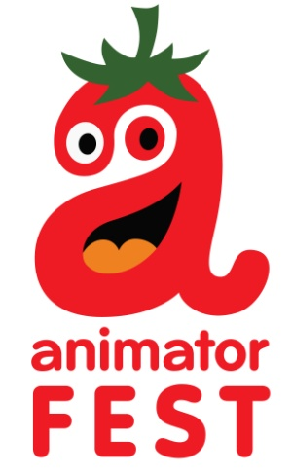

ABOUT THE FESTIVAL

The Festival of Animated Film for Children and Youth of Serbia was founded in 2013 with the aim of promoting the national production of animated film made by young authors, up to 18 years old. It is based upon the concept of competition programme divided into 2 categories: Children - under 15 years of age and Youth - 15 to 18 years old, but it is also followed by numerous following programmes including exhibitions, masterclass workshops, film retrospectives of other similar festivals.
Even though it was originally created as a creative platform for popularization and development of the national animated film production, in 2017 the festival grew into an international cultural event by enriching it's competition programme with a European selection of animated films for children and youth.
As of 2018, the festival was upgraded with one more competition category: 3rd category for films aimed at children and youth but made by professionals, students and others alike.
The Festival takes place in Jagodina every September with the support of the Ministry of Culture of the Republic of Serbia and the City of Jagodina.
The festival is aimed at promoting the art of animation from European countries and serves as a place of gathering for young people willing to exchange and build new creative ideas.
8th Animator fest will take place in Jagodina, Serbia, 16th to 20th September 2020.

ADMISSION CONDITIONS
Only animated films not longer than 15 minutes will be accepted (using ‘frame by frame’ or computer animation techniques or combining live action and animation in which case animation must take more than 50% of running time)
Works coming from non European countries cannot be accepted for competition, but can be screened at the festival.
We accept films made after January 1st 2019.
One school or author can submit more than one film according to festival rules.

There is no entry fee.

ENTRIES AND REGISTRATION
For pre- selection films must be sent only in MP4 format.
The Entry form should be sent by e-mail to animatorfestjagodina@gmail.com.
The Entry Form must be sent together with a digital copy of the film for pre-selection alongside two or more stills from the film (300 dpi), a film synopsis (maximum 500 characters) and a brief biography of the author.
Films can also be submitted via platforms FilmFreeway and Festhome.

Deadline for submission is 15.6.2020.
The participants will be informed about the results of pre-selection by e-mail, before August 5th.

SUBTITLING
All the films need to have English subtitles incorporated, except if the language spoken in the film is English.

ACCEPTING THE RULES
The participation (sending film for pre-selection and signing the Entry Form) in the Animator fest implies unconditional acceptance of the terms and conditions set forth in these Regulations. Films once applied for the festival cannot be withdrawn.
Festival confirms that all the authors` rights,
clearly indicated in the Entry Form, will be guaranteed.

Animator fest
Kulturni centar Jagodina
2020

