7. AНИМАТОР ФЕСТ - ЕVROPSKI FESTIVAL ANIMIRANOG FILMA DECE I MLADIH
7th ANIMATOR FEST - EUROPEAN YOUTH FESTIVAL OF ANIMATED FILM
18th - 22nd September 2019. Jagodina, Serbia
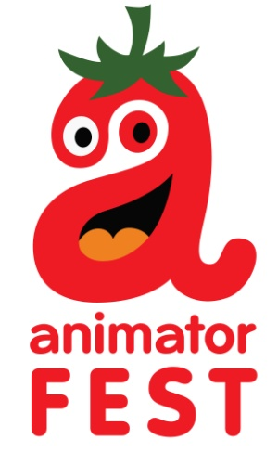

ABOUT THE FESTIVAL
Organized by the Cultural centre ‘Svetozar Markovic’ in Jagodina, Serbia, Animator fest was founded in 2013 and is supported by the Serbian Ministry of Culture and Information.
The festival is aimed at promoting the art of animation from European countries and serves as a place of gathering for young people willing to exchange and build new creative ideas.
Animator fest will take place in Jagodina, 18th to 22nd September 2019.
The festival’s programme represents youth film production of schools and individual authors divided into 2 categories: authors under 15 years of age and authors 15 to 18 years old.
As of 2018, the festival was upgraded with one more competition category: 3rd category for films aimed at children and youth but made by professionals, students and others alike.

ADMISSION CONDITIONS
Only animated films not longer than 15 minutes will be accepted (using “frame by frame” or computer animation techniques or combining live action and animation in which case animation must take more than 50% running time)
Works coming from non European countries cannot be accepted for competition, but can be screened at the festival.
We accept films made after 1st January 2017.
One school or author can submit more than one film according to festival rules.
There is no entry fee.

ENTRIES AND REGISTRATION
For pre- selection films must be sent only in MP4 format.
The Entry form should be sent by e-mail to animatorfestjagodina@gmail.com.
The Entry Form must be sent together with a digital copy of the film for pre-selection alongside two or more stills from the film (300 dpi), a film synopsis (maximum 500 characters) and a brief biography of the author.

Deadline for submission is 31.7.2019.
The participants will be informed about the results of pre-selection by e-mail, before August 15th.

SUBTITLING
All the films need to have English subtitles incorporated, except if the language spoken in the film is English.

ACCEPTING THE RULES
The participation (sending film for pre-selection and signing the Entry Form) in the Animator fest implies unconditional acceptance of the terms and conditions set forth in these Regulations. Films once applied for the festival cannot be withdrawn.
Festival confirms that all the authors` rights,
clearly indicated in the Entry Form, will be guaranteed.

Animator fest
Kulturni centar Jagodina
2019.

