10. ANIMATOR FEST/ EVROPSKI FESTIVAL ANIMIRANOG FILMA DECE I MLADIH
10th ANIMATOR FEST - EUROPEAN YOUTH FESTIVAL OF ANIMATED FILM
31. 08 – 4. 09. 2022. Jagodina/ Serbia

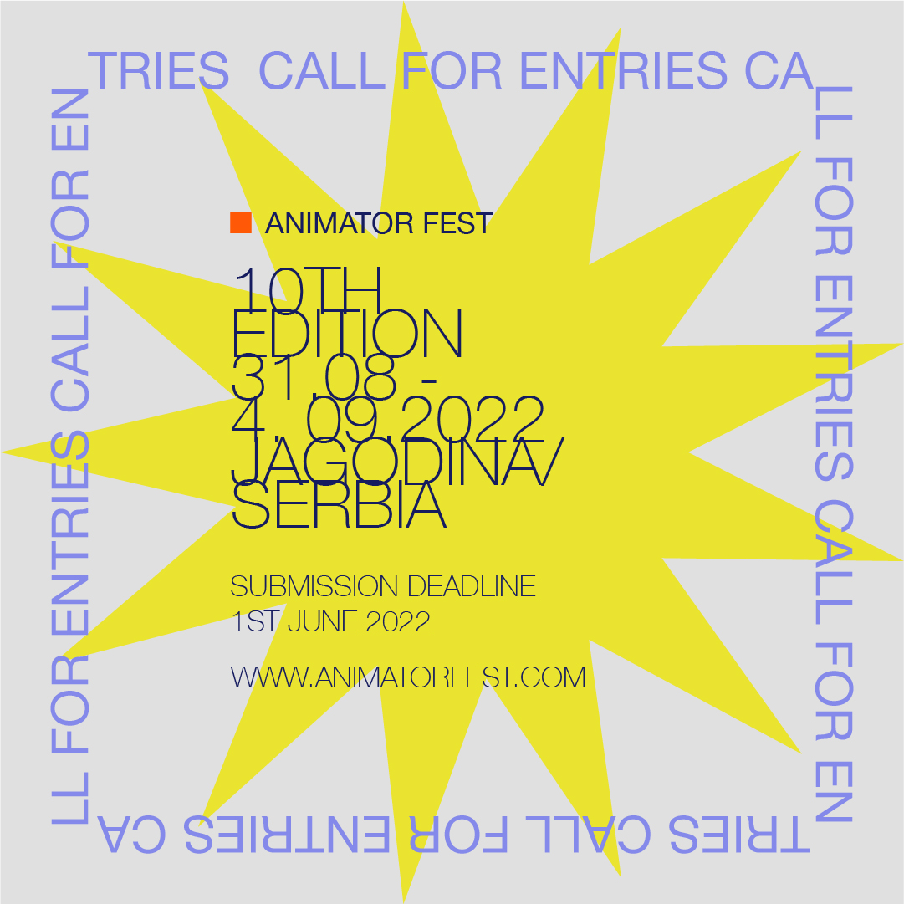

PRIJAVA ZA FESTIVAL/ ENTRY FORM
Rok za prijavu / Deadline for entries: 1.0.6.2022

ORIGINALNI NASLOV FILMA / ORIGINAL FILM TITLE:
NASLOV FILMA NA ENGLESKOM / ENGLISH TITLE:
ZEMLJA/ COUNRTY:

KATEGORIJA / CATEGORY:
- Kratkometražni animirani film - internacionalna konkurencija / SHORT FILMS EUROPEAN COMPETITION
- Kratkometražni animirani film – nacionalna konkurencija / SHORT FILMS NATIONAL COMPETITION
- Studentska animacija- internacionalna konkurencija/ STUDENT ANIMATION EUROPEAN COMPETITION
- Studentska animacija- inacionalna konkurencija/ STUDENT ANIMATION NATIONAL COMPETITION
- Dečiji i omladinski animirani film / CHILDREN AND YOUTH ANIMATION FILM

Individualan rad / Individual creation
Škola, klub ili studio/ School or film club creation
Film nastao na radionici / Workshop or course project

REDITELJ/ DIRECTOR
Adresa / Address:
Telefon / Telephone:
E- mail

Škola ili producent / School or Producer:
Adresa / Address:
Telefon / Telephone:
E- mail

TRAJANJE / RUNNING TIME:
GODINA PROIZVODNJE / PRODUCTION DATE:
Scenario / Script:
Animacija / Animation:
Montaža / Editing:
Muzika/ Music:

KRATAK SADRŽAJ FILMA (do 50 reči) / FILM SYNOPSIS (max. 50 words):

TEHNIKE/ TECHNIQUES
Crtež na papiru/ Drawings on paper
Plastelin/ Clay
Kolaž/ Cut-outs
Piksilacija/ Pixilation
Lutka/ Puppets
Druge tehnike/Other techniques

Dijalozi/Dialogues Da/Yes Ne/No
Titlovi / Subtitles Da/Yes Ne/No

Autorizacija / Authorization
Dozvoljavam da se 5% trajanja filma može prikazati na televiziji u cilju promocije festivala.
I authorize the screening of my film up to 5 % of its length on television for information purposes.
Da/Yes Ne/No

Slažem se sa prikazivanjem mog filma na javnim nekomercijalnim projekcijama kojima se promoviše Animator fest, u školama, kulturnim institucijama, i festivalima.
I agree with the public screening of my film in special programs promoted by Animator fest with no commercial purposes, and that are included in cultural activities organized by schools, cultural associations, film societies and festivals.
Da/Yes Ne/No

Slažem se da se fotografije i crteži iz filma mogu koristiti na internetu u promotivne svrhe.
I agree to the use of photos of the film on the Internet for promotional purposes.
Da/Yes Ne/No

Pročitajte pravila, popunjenu prijavu zajedno sa filmom i fotografijama iz filma pošaljite elektronskim putem (koristeći WeTransfer, SendSpace, Dropbox itd.) najkasnije do 1. Juna 2022. na e-mail adresu: animatorfestjagodina@gmail.com

Read the Regulations, complete the entry form and send it together with films and film stills (using Wetransfer, SendSpace, Dropbox…) via e-mail animatorfestjagodina@gmail.com no later than June 1st 2022

The Entry Form is valid without signature or seal and means approval of Festival Regulations.

Potpis /Signature

